類神經網路

適應性共振理論(ART)神經網路
Adaptive Resonance Theory (ART) Neural Network

1. 向量量化(VQ)分類
2. ART神經網路原理
3. ART1架構與學習演算法
4.ART衍生模型與相關參考文獻
5. ART1範例
6. ART2演算法

陳慶瀚
義守大學電機系
2002年5月8日
1. 向量量化(VQ)分類
K-Means是一種靜態的、無監督式的分類方法，也就是分類的叢聚中心(Cluster center)數目必須事前決定，而VQ(Vector Quantization)是一種動態的、無監督式的分類方法，叢聚中心數目在分類之前不需給定，而由演算法在分類的同時決定是否動態地增加叢聚中心數目。
VQ開始分類時總是以第一個輸入的特徵向量作為第一個叢聚中心，當一個新的特徵向量輸入時，它將比較該向量與所有叢聚中心的Euclidean距離：
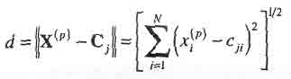
接著選出與特徵向量最接近的叢聚中心：
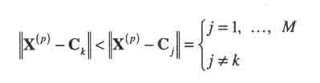
最接近的叢聚中心決定後，再將d與一個距離的臨界值µ比較，如果
─ d<µ，則接受Ck作為分類結果，並重新計算Ck的座標位置：
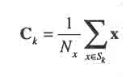

─ 否則，產生一個新的類別，並指定該特徵向量作為叢聚中心。
2. ART神經網路原理
stability-plasticity dilemma:
- How can a learning system be designed to remain plastic, or adaptive, in response to significant events and yet remain stable in response to irrelevant events?
- How does the system know how to switch between its stable and its plastic modes to achieve stability without rigidity and plasticity without chaos?
- In particular, how can it preserve its previously learned knowledge while continuing to learn new things?
- And, what prevents the new learning to wash away the memories of prior learning?
Grossberg 根據人類認知、學習的原理提出自組織的ART神經網路模型(http://cns-web.bu.edu/)：
- Grossberg, S. (1976a), "Adaptive pattern classification and universal recoding, I: Parallel development and coding of neural feature detectors", Biological Cybernetics 23, 121-134.
- Grossberg, S. (1976b), "Adaptive pattern classification and universal recoding, II: Feedback, expectation, olfaction, and illusions", Biological Cybernetics 23, 187-202.
要使類神經網路在舊有的記憶之下學習新的事物，就必須克服穩定性與可塑性的矛盾。因此，為了保持類神經網路的可塑性， ART在設計上採用動態架構；為了保持系統的穩定性， ART則是利用由順向與回授所構成的雙向記憶，來控制系統學習的Stability/Plasticity行為。
何時該新增神經元來擴充學習，何時只需更新舊的記憶呢 ？為了能夠決定分類的粗細程度， ART在設計時便引進了 一個參數，稱為警戒參數（Vigilance parameter）。當警戒參數定的越大，越容易增加新的神經元，因此分類結 果也就越細。相反地，警戒參數越小，越容易只修改舊的 神經元而不需增加新的神經元，因此分類的結果就越粗。
3. ART1架構與學習演算法
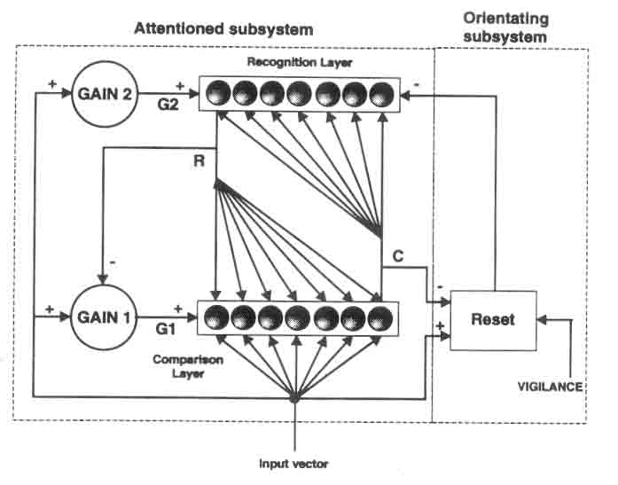
ART 的架構可分為兩個部份：
第一部份稱為Attentional subsystem，是由兩個神經層F1,F2所構成。第二部份稱為Orienting subsystem，是由一個重置機構所組成，其主要的工作是輔助Attentional subsystem，使之能 夠學習陌生樣本，而不至於擾亂原有的記憶。
對於任意一筆輸入的特徵向量I，ART網路會試圖將它分類在先前已經記憶的類別或者創造一個新類別。首先，I 輸入F1層(Comparison Layer)的神經元。F1層有三個輸入來源，一個是外部的特徵向量輸入，一個是F2的回授訊號，第三個是增益控制訊號。
當一個神經元的三個訊號來源至少有兩個是致能狀態(active，即binary value=1)時，則此神經元就進入致能狀態，這稱為2/3法則(2/3 rule)。
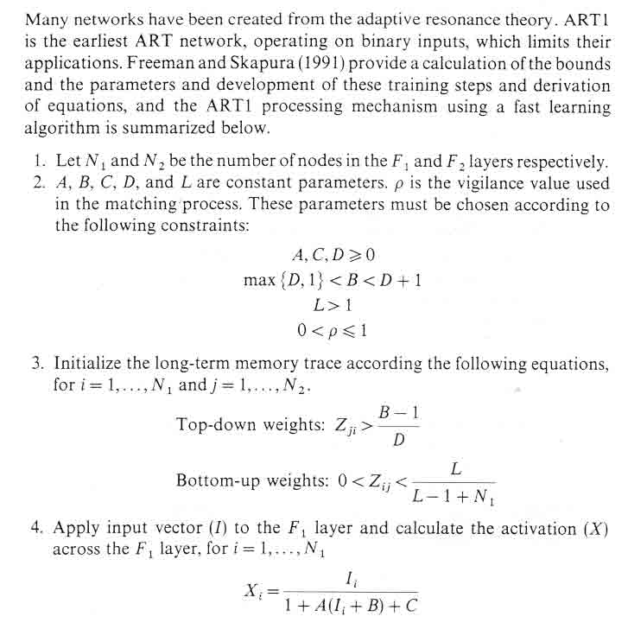
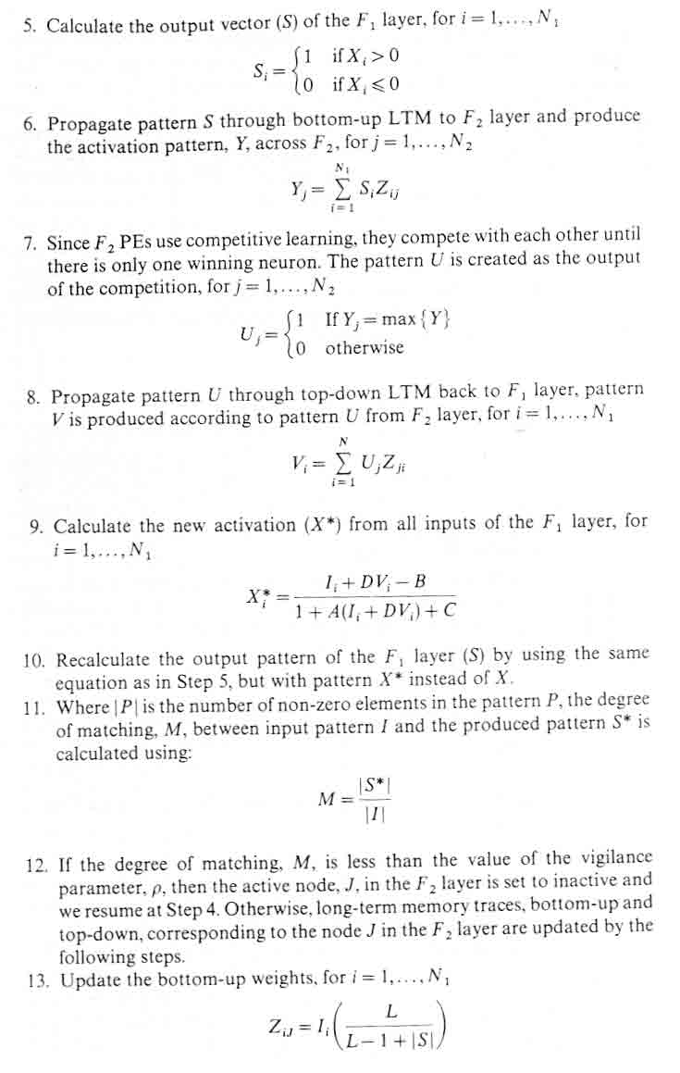
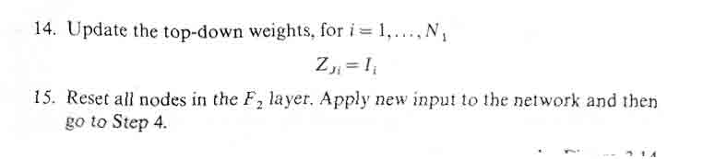
4.ART衍生模型與相關參考文獻
ART-1
This is a binary version of ART, i.e., it can cluster binary input vectors.
References
- [Carpenter87a]
ART-2
This is an analogue version of ART, i.e. it can cluster real-valued input vectors.
References
- [Carpenter87b]
ART-2A
This refers to a fast version of the ART2 learning algorithm.
References
- [Carpenter91a]
ART-3
This network is an ART extension that incorporates "chemical transmitters" to control the search process in a hierarchical ART structure.
References
- [Carpenter90]
ARTMAP
This is a supervised version of ART that can learn arbitrary mappings of binary patterns.
References
- [Carpenter91b]
Fuzzy ART
This network is a synthesis of ART and fuzzy logic.
References
- [Carpenter91c]
Fuzzy ARTMAP
This is supervised fuzzy ART.
References
- [Carpenter92]
- [Carpenter95b]
Distributed ART and ARTMAP (dART and dARTMAP)
These models learn distributed code representations in the F2 layer. In the special case of winner-take-all F2 layers, they are equivalent to Fuzzy ART and ARTMAP, respectively.
References
- [Carpenter97]
- [Carpenter98b]

- Carpenter, Gail A., Grossberg, Stephen (1987a) "A Massively Parallel Architecture for a Self-Organizing Neural Pattern Stephen Recognition Machine", Computer Vision, Graphics and Image Processing, Vol. 37, 1987, pp.54-115
- Carpenter, Gail A., Grossberg, Stephen (1987b) "Invariant pattern recognition and recall by an attentive self-organizing ART architecture in a nonstationary world", In Maureen Caudill and Charles Butler, editors, Proceedings of the IEEE First International Conference on Neural Networks, San Diego, CA, pp. II-737-II-745, June 1987, IEEE
- Carpenter, Gail A., Grossberg, Stephen (1988) "The ART of Adaptive Pattern Recognition by a Self-Organizing Neural Network", IEEE Computer, Volume 21, Number 3, pp.77-88, March 1988
- Carpenter, Gail A. (1989) "Neural Network Models for Pattern Recognition and Associative Memory", Neural Networks, Vol.2, 1989, pp.243-257
- Carpenter, Gail A., Grossberg, Stephen (1990) "ART3: Hierarchical Search Using Chemical Transmitters in Self-Organizing Pattern Recognition Architectures", Neural Networks, 1990, Volume 3, pp.129-152
- Carpenter, Gail A., Grossberg, Stephen, Rosen, D.B. (1991a) "ART2-A: An Adaptive Resonance Algorithm for Rapid Category Learning and Recognition", Neural Networks, 1991, Volume 4, pp.493-504
- Carpenter, Gail A., Grossberg, Stephen, Reynolds, J.H. (1991b) "ARTMAP: Supervised Real-Time Learning and Classification of Nonstationary Data by a Self-Organizing Neural Network", Neural Networks, 1991, Volume 4, pp.565-588
- Carpenter, Gail A., Grossberg, Stephen, Rosen, D.B. (1991c) "Fuzzy ART: Fast Stable Learning and Categorization of Analog Patterns by an Adaptive Resonance System", Neural Networks, 1991, Volume 4, pp.759-771
- Carpenter, Gail A., Grossberg, Stephen, Markuzon, N., Reynolds, J.H., Rosen, D.B. (1992) "Fuzzy ARTMAP: A Neural Network Architecture for Incremental Supervised Learning of Analog Multidimensional Maps", IEEE Transactions on Neural Networks, September 1992, Volume 3, Number 5, pp.698-713
- Carpenter, Gail A., Ross, W. (1995a) "ART-EMAP: A neural network architecture for learning and prediction by evidence accumulation", IEEE Transactions on Neural Networks, July 1995, 6(4):805-818
- Carpenter, Gail A., Grossber, Stephen, Reynolds, J.H. (1995b) "A Fuzzy ARTMAP Nonparametric Probability Estimator for Nonstationary Pattern Recognition Problems", IEEE Transactions on Neural Networks, November 1995, 6(6):1330-1336
- Carpenter, Gail A. (1997) "Distributed Learning, Recognition, and Prediction by ART and ARTMAP Neural Networks", Neural Networks, 1997, Volume 10, No. 8, pp.1473-1494
- Carpenter, Gail A., Markuzon, Natalya (1998a) "ARTMAP-IC and medical diagnosis: Instance counting and inconsistent cases", Neural Networks, 1998, Volume 11, No. 2, pp.323-336
- Carpenter, Gail A., Milenova, Borina L., Noeske, Benjamin W. (1998b) "Distributed ARTMAP: a neural network for fast distributed supervised learning", Neural Networks, 1998, Volume 11, No. 5, pp.793-813
5. ART1範例
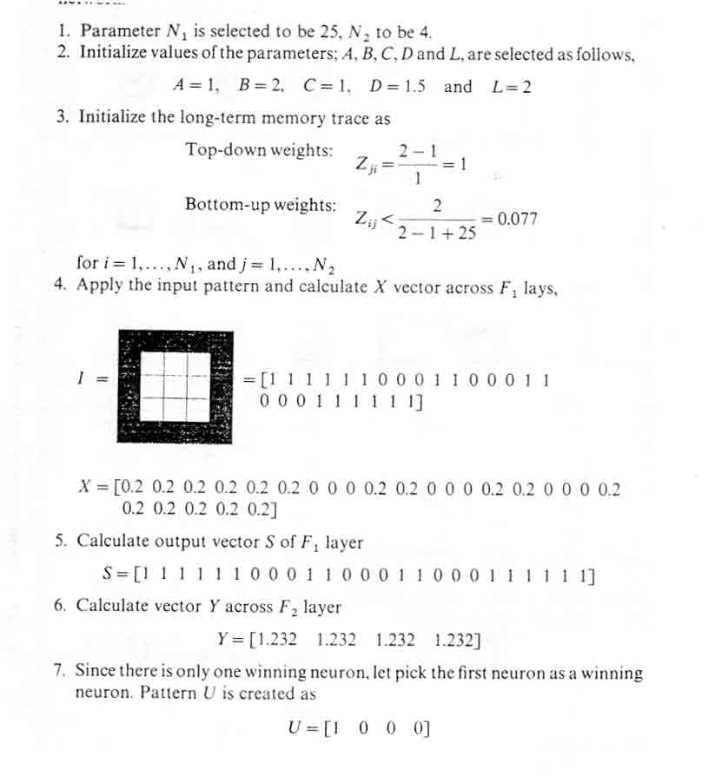
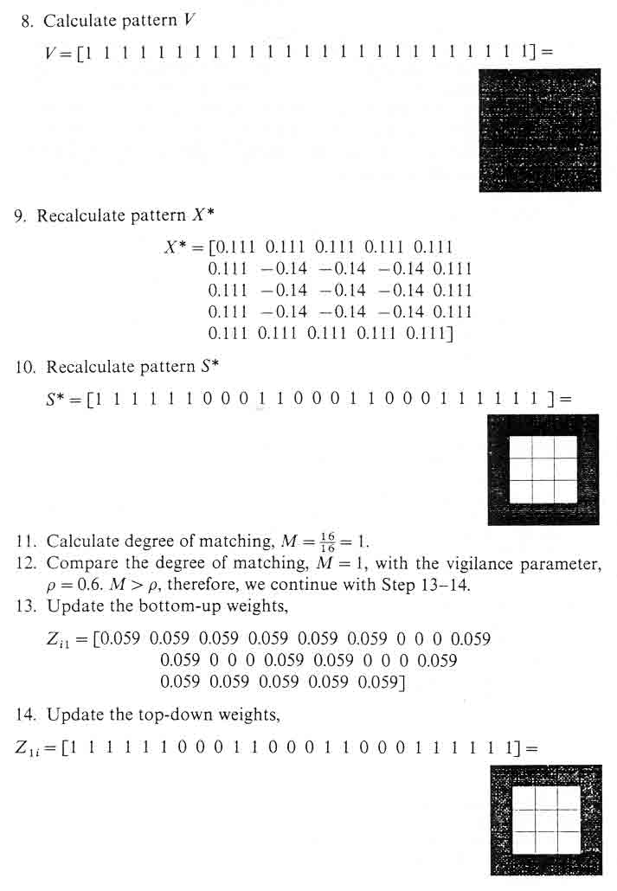
6. ART2演算法
