Cellular Neural Networks(細胞元神經網路)

A cellular neural network (CNN) is an artificial neural network which features a multi-dimensional array of neurons and local interconnections among the cells.
The original CNN paradigm was first proposed by Chua and Yang in 1988. The two most fundamental ingredients of the CNN paradigm are: the use of analog processing cells with continuous signal values, and local interaction within a finite radius. A CNN is a nonlinear analog circuit which processes signals in real time. It is made of a massive aggregate of regularly spaced cloned circuit, called cells, which communicate with each other directly only through their nearest neighbors.
Ref : Cellular Automata

Architecture of Cellular Neural Networks

Any cell in a CNN is connected only to its neighbor cells. The adjacent cells can interact directly with each other. Cells not directly connected together may affect each other indirectly because of the propagation effects of the dynamics of CNNs. An example of a two-dimensional CNN is shown below.
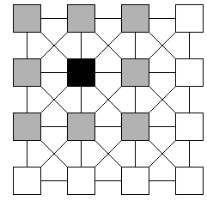
Every cell is influenced by a limited number of cells in its environment. This locality of connections between the units is the main difference between CNNs and other neural networks. Large CNN chips can be implemented using VLSI techniques.
The figure above shows the emphasized cell (black) connected to the nearest neighbors (gray). The cells marked in gray represent the neighborhood cells of the black cell. The neighborhood includes the black cell itself. This is called a "3*3-neighborhood".
Similarly, we could define a "5*5-neighborhood", a "7*7-neigborhood" and so on.
The basic circuit unit of CNNs is called a cell. It contains linear and nonlinear circuit elements, which typically are linear capacitors, linear resistors, linear and nonlinear controlled sources, and independent sources. All the cells of a CNN have the same circuit structure and element values. A typical circuit of a single cell is shown in the figure below.
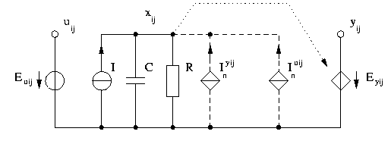

Each cell contains one independent voltage source E _{uij} (Input), one independent current source I (Bias), several voltage controlled current sources I_{n}^{u ij}, I_{n}^{y ij}, and one voltage controlled voltage source E_{y ij} (Output). The controlled current sources I_{n}^{u ij} are coupled to neighbor cells via the control input voltage of each neighbor cell. Similarly, the controlled current sources I_{n}^{y ij} are coupled to their neighbor cells via the feedback from the output voltage of each neighbor cell.
The cell C(i,j) has direct connections to its neighbors through two kinds of weights: the feedback weights a(k,l;i,j) and the control weights b(k,l;i,j), where the index pair (k,l;i,j) represents the direction of signal from C(i,j) to C(k,l). The coefficients a(k,l;i,j) are arranged in the feedback-Template or A-Template. The coefficients b(k,l;i,j) are arranged in the control-Template or B-Template.
The A-Template and the B-Template are assumed to be the same for all the cells in the network. The global behavior of a CNN is characterized by a Template Set containing the A-Template, the B-Template, and the Bias I.
If we assume a "3*3-neighborhood", the Template Set consists of 19 coefficients.
The external input to the cell is typically assumed to be constant over a certain operation interval. Therefore, the total input current to the cell is given by the weighted sum of control inputs and weighted sum of feedback outputs. In addition, a constant bias term (I) is added to the cell. Due to the capacitance C and resistance R, the state voltage x(i,j) satisfies the following differential equation:
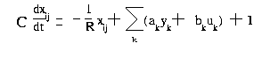
k denotes the neighborhood of the specific cell

Without loss of generality, the time constant T = R*C can be set to 1.
The only nonlinear element in each cell is a piecewise-linear voltage controlled voltage source with characteristic
y(i,j) = f(x(i,j)).
A widely used nonlinearity is the piecewise-linear function as given by:
y(i,j) = f(x(i,j)) = 0.5*(|x + 1| - |x - 1|)
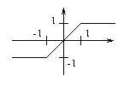

The block diagram of a cell C(i,j) is shown in the figure below.
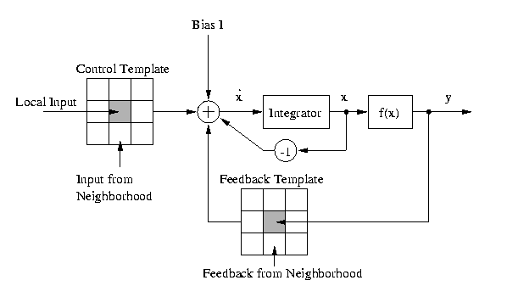

Global behavior of Cellular Neural Networks

In image processing, n-by-m rectangular grid arrays are often used. n and m are the numbers of rows and columns, respectively. Each cell in a CNN corresponds to an element of the array.
Assuming that each cell is connected to its nearest neighbors only ("3*3-neighborhood") and that the local connections of a cell do not depend on the cell's position, the Template set contains 19 coefficients (A-Template: a1 .. a9, B-Template: b1 .. b9, Bias I). The behavior of the CNN is completely determined by this Template set.
New CNN-Templates for arbitrary tasks may be found using a training algorithm, or by defining local rules for a given global task. The local rules describe a cell's equilibrium state depending on the inputs and outputs of the neighbor cells. The inputs and the outputs of the neighbor cells are assumed the be constant. The dynamics of the cell is not specified.
If Template values for the local rules are found, simulations are very helpful to test the dynamic global behavior of the entire clone of cells.
Optimal coefficient calculation leads to solutions which converge after short time. This means that the output of every cell reaches its final output y=+1 or y=-1 after short time.

Characteristics of a simple CNN Template

- Template set
We assume "3*3-neighborhood". A simple Template set for edge extraction is given by:
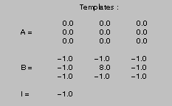
- Global task: Binary edge detection
If the input image is a binary image (black and white), the output of the CNN will be a binary image showing the edges of the input image only. If the input image has intermediate (gray) values, the operation of the CNN with this simple Template set is not well defined..
Input: U(t) = static binary image
Initial state: X(0) = arbitrary (reason: Feedback Template = 0)
Output: Y(t) converges toward a binary image showing all edges of the input image.
- Local rules
Regarding the global tasks, we can define local rules for a single cell. The rules are deduced from the following reflections:
1. A white pixel never turns black.
2. A black pixel turns white if it is surrounded by black pixels
3. A black pixel never turns white, when at least one neighbor cell is white. In this case, this cell belongs to the edge of the object
 | Input u(i, j) | Output y(i, j) (t = infinity)
1. | white pixel | white, independent of neighbors
2. | black pixel | white, if all nearest neighbors are black
3. | black pixel | black, if at least one nearest neighbor is white

- Global behavior
The screenshots below show the correct behavior of the Template set.
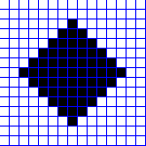
The input picture above is the input picture of the CNN. It does not change in this small time period. The four pictures below show the dynamcal behavior of the entire grid. Starting with the initial state on the left side, the pictures show the state of the CNN cluster at t = 0.2, t = 0.5 and t = 2.
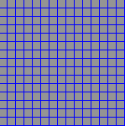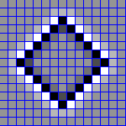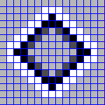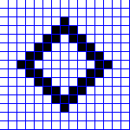
After two time units (t = 2), the output of the CNN shows the edges of the input image. The Template set produces the desired output.

Application Potential

CNNs can be used in many scientific applications:
In signal processing, CNNs show great promise in solving many complex problems that cannot be solved satisfactorily using conventional approaches.
- solve the maximum-likelihood estimation of signals in the presence of intersymbol interference and white Gaussian noise
In image processing that deals with gray-scale image inputs, CNNs can be applied to perform
- feature extraction & classification
- motion detection & estimation
- collision avoidance
- object counting & size estimation
- path tracking
In analyzing 3-D complex surfaces, the CNN is capable of
- detecting minima and maxima
- detecting area with gradients that exceed a given threshold
In solving partial differential equations, CNN is suitable for reducing non-visual problems to geometric maps for
- thermographic maps
- antenna-array images
- medical maps and images

