Cellular Automata
Cellular automata are computer simulations that try to emulate the way the laws of nature are supposed to work in nature. Possibly, they could tell us whether the reductionistic approach research always has adopted is realistic. Is it really possible to imagine our fascinating, complex and sometimes seemingly random world as created by a small set of relatively simple rules?
Cellular automata can never give definitive answers to these questions, since they don't claim to emulate nature in more than a rough way. But they could give us an idea of how reasonable the thought of a world governed by simple rules is.

1. Definition
A cellular automaton is an array of identically programmed automata, or "cells", which interact with one another.
The arrays usually form either a 1-dimensional string of cells, a 2-D grid, or a 3-D solid. Most often the cells are arranged as a simple rectangular grid, but other arrangements, such as a honeycomb, are sometimes used.
The essential features of a cellular automaton ("CA" for short) are:
- its STATE is a variable that takes a different separate for each cell. The state can be either a number or a property. For instance if each cell represents part of a landscape, then the state might represent (say) the number of animals at each location or the type of forest cover growing there.
- its NEIGHBOURHOOD is the set of cells that it interacts with. In a grid these are normally the cells physically closest to the cell in question.

2. One-dimensional cellular automata
Life is an example of the more general term "cellular automata". Despite its relatively simple rules, Life is still a system not well suited to the sort of exhaustive exploration scientists are so fond of. Therefore, in 1982 Stephen Wolfram set out to create an even simpler, one-dimensional system.
The main advantage of a one-dimensional automaton is that changes over time can be illustrated in a singe, two-dimensional image and that each cell only has two neighbors. There are only 256 possible rules if the state of a cell is dependent on its own and its two neighbors states in the previous generation, which makes it possible to examine all the results of all rule sets. The question was if even such a simplified system could display complex behavior.
The answer is "yes". In the same way as in Life there are rules that yield chaos and those who yield static states. But what was interesting was of course the rules who gave results inbetween, a state vaguely called "complex", the state of biological life. Even this system proved capable of displaying complex behavior, though in less spectacular forms than Life.
Worth noting is that gliders abound in most one-dimensional rule systems. These show up as diagonal lines in the image. Just about all rule systems create diagonal patterns. Those who do gliders out of everything are obviously the ones where the state of the next generation only depends on the state of the left / right neighbor in the previous generation.
The main reason one-dimensional systems seem so much more trivial and boring than its two-dimensional equivalents is probably that our vision is adapted to two-dimensional pictures, which makes it easier for us to recognize patterns and organisms / agglomerations in 2-D (a not entirely trivial task, which is illustrated by the difficulty in telling a computer how to do it). Also, much smaller populations are generally used. The life board above had 2,500 cells, double or triple the horizontal number of pixels on your screen, while this board only has 100 cells per generation.
Still, it seems possible to dream of one-dimensional organisms at large enough populations, even if we probably would not recognize them even if we saw them. Wolfram's hypothesis that complexity can arise of out of almost arbitrarily simple rules seems to be confirmed.
3. Two-dimensional cellular automata
Here are some simple neighbourhoods (cells marked n) of a cell (C) in a 2-D grid ...
n n n n n n n n
n C n n C n n C n n n n
n n n n n n n n
- its PROGRAM is the set of rules that defined how its state changes in response to its current state, and that of its neighbours.
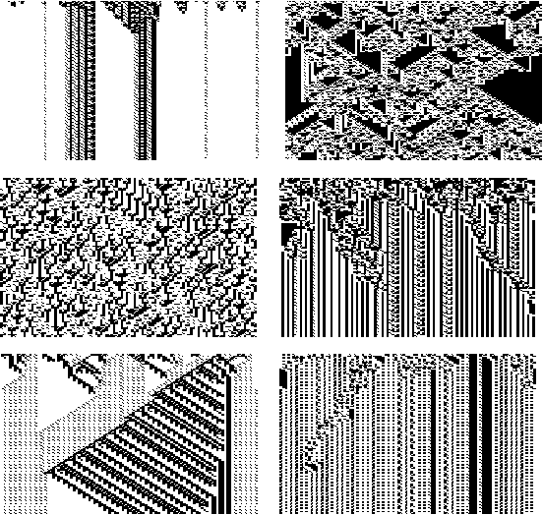
Example - Fabric patterns
Imagine a CA consisting of a line of cells as follows:

states : 0 or 1
neighbourhood : the two adjacent cells N C N
rules : the following list shows the new state of a cell for each possible local "configuration", i.e. arrangement of states for the cell and its two neighbours. Because there are two possible states ( 0 or 1) for each of 3 cells, there are 2^3 = 8 rules required. Here they are
0 0 0 -> 0 1 0 0 -> 1
0 0 1 -> 1 1 0 1 -> 1
0 1 0 -> 1 1 1 0 -> 0
0 1 1 -> 0 1 1 1 -> 0

Suppose that we start with just a single cell in state 1. Then here is how the array will change with time (here "." denotes 0 for clarity).

Time 0 : . . . . . . . . . . 1 . . . . . . . . . .
Time 1 : . . . . . . . . . 1 1 1 . . . . . . . . .
Time 2 : . . . . . . . . 1 . . . 1 . . . . . . . .
Time 3 : . . . . . . . 1 1 1 . 1 1 1 . . . . . . .
Time 4 : . . . . . . 1 . . . 1 . . . 1 . . . . . .
Time 5 : . . . . . 1 1 1 . 1 1 1 . 1 1 1 . . . . .
Time 6 : . . . . 1 . . . 1 . . . 1 . . . 1 . . . .

4. Properties of Cellular Automata

Self-organization. Notice that when we plot the successive states as shown in the above example a pattern emerges. Even if the line of cells starts with a random arrangement of states, the rules force patterns to emerge (Fig. 1).
Life-like behaviour. Empirical studies by Wolfram and others show that even the simple linear automata above behave in ways reminiscent of complex biological systems. For example, the fate of any initial configuration of a cellular automaton is either:
to die out;
become stable or cycle with fixed period;
to grow indefinitely at a fixed speed;
to grow and contract irregularly.

"Thermal" behaviour. In the above example of a linear automaton 6 of the 8 rules forced a change in the state of the cell concerned. In general, models that force a change of state for few configurations tend to "freeze" into fixed patterns, whereas models that change the cell's state in most configurations tend to behave in a more active "gaseous" way. That is fixed patterns do not emerge.

5. Building Cellular Automata

The Cell
The basic element of a CA is the cell. A cell is a kind of a memory element and stores - to say it with easy words - states. In the simplest case, each cell can have the binary states 1 or 0. In more complex simulation the cells can have more different states. (It is even thinkable, that each cell has more than one property or attribute and each of these properties or attributes can have two or more states.)

The Lattice
These cells are arranged in a spatial web - a lattice. The simplest one is the one dimensional "lattice", meaning that all cells are arranged in a line like a string of perls. The most common CA´s are built in one or two dimensions. Whereas the one dimensional CA has the big advantage, that it is very easy to visualize. The states of one timestep are plotted in one dimension, and the dynamic development can be shown in the second dimension. A flat plot of a one dimensional CA hence shows the states from timestep 0 to timestep n. Consider a two dimensional CA: a two dimensional plot can evidently show only the state of one timestep. So visualizing the dynamic of a 2D CA is by that reason more difficult.
By that reasons and because 1D CA´s are generally more easy to handle (there is a much smaller set of possible rules, compared to 2D CA´s, as will be explained in the next section) first of all the one dimensional CA´s have been exploited be theoreticians. Most theoretical papers available deal with properties of 1D CA´s.

Neighbourhoods
Up to now, these cells arranged in a lattice represent a static state. To introduce dynamic into the system, we have to add rules. The "job" of these rules is to define the state of the cells for the next time step. In cellular automata a rule defines the state of a cell in dependence of the neighbourhood of the cell.
Different definition of neighbourhoods are possible. Considering a two dimensional lattice the following definitions are common:
von Neumann Neighbourhood
four cells, the cell above and below, right and left from each cell are called the von Neumann neighbourhood of this cell. The radius of this definition is 1, as only the next layer is considered.
Moore Neighbourhood
the Moore neighbourhood is an enlargement of the von Neumann neighbourhood containing the diagonal cells too. In this case, the radius r=1 too.
Extended Moore Neighbourhood
equivalent to description of Moore neighbourhood above, but neighbourhood reaches over the distance of the next adjacent cells. Hence the r=2 (or larger).
Margolus Neighbourhood
a completely different approach: considers 2x2 cells of a lattice at once. for more details take a look at the Applications
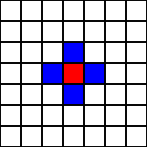 | 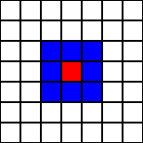 | 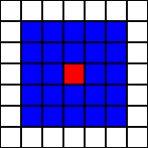
von Neumann Neighbourhood | Moore Neighbourhood | Extended Moore Neighbourhood
The red cell is the center cell, the blue cells are the neighbourhood cells. The states of these cells are used to calculate the next state of the (red) center cell according to the defined rule.
As the number of a cells in a lattice has to be finite (by practical purposes) one problem occurs considering the proposed neighbourhoods described above: What to do with cells at borders? The influence depends on the size of the lattice. To give an example: In a 10x10 lattice about 40% of the cells are border cells, in a 100x100 lattice only about 4% of the cells are of that kind. Anyway, this problem must be solved. Two solutions of this problem are common:
- Opposite borders of the lattice are "sticked together". A one dimensional "line" becomes following that way a circle, a two dimensional lattice becomes a torus.
- the border cells are mirrored: the consequence are symmetric border properties.
The more usual method is the possibility 1.

6. Applying Rules
An example of "macroscopic" dynamic resulting from local interaction is "the wave" in a - say soccer-stadium. Each person reacts only on the "state" of his neighbour(s). If they stand up, he will stand up too, and after a short while, he sits down again. Local interaction leads to global dynamic. One can arrange the rules in two (three) classes:
- every group of states of the neighbourhood cells is related a state of the core cell. E.g. consider a one-dimensional CA: a rule could be "011 -> x0x", what means that the core cell becomes a 0 in the next time step (generation) if the left cell is 0, the right cell is 1 and the core cell is 1. Every possible state has to be described.
- "Totalistic" Rules: the state of the next state core cell is only dependent upon the sum of the states of the neighbourhood cells. E.g. if the sum of the adjacent cells is 4 the state of the core cell is 1, in all other cases the state of the core cell is 0.
- "Legal" Rules: a special kind of totalistic rules are the legal rules. As it is not of advantage in most cases to use rules that produce a pattern from total zero-state lattices (all cells in the automaton are 0), Wolfram defined the so called legal rules . These rules are a subset of all possible rules, a selection of rules that produce no one´s from zero-state lattices.
Case 1 shows why one-dimensional automata are that popular in theoretical studies. if only the left, the right neighbour and the cell itself is considered in the rules (r=1), there are 256 possible rules totally:
2 ³=8 possible states for three binary digits, each of these 8 states can produce a 1 or a 0 for the center cell in the next generation. Hence 2⁸=256 rules are existing.
So in general terms the number of rules can be calculated by k^{kn}, where k is the number of states for the cell and n is the number of neighbours (including the core cell itself). So we can easily see, that for a two-dimensional CA with Moore neighbourhood, 2 states and r=1 follows k=2 and n=9. So 2²⁹=262.144 possible rules exist. A comprehensive study of all rules in higher dimensional automata is thus not easily possible.
Another important variation are the reversible cellular automata. The "only" difference to the CA´s described above is, that the time development of the system is completely reversible. That means, that at any time-step of the development the rules allow to go forward or back in time without losing any information.

